|  |  |  |  |  |  |  |  |
| --- | --- | --- | --- | --- | --- | --- | --- |
| 桃園市立青埔國中**107**學年度第**2**學期**9**年級 **總領域補考-英文(題庫)** | | | | | | | |
| 領域  （科目） | 英語 | 範圍 | 1~6冊 | | | 得分 |  |
| 班級 | **9**年 班 | 姓名 |  | 座號 |  |

一、辨識句意：根據文句敘述，選出符合描述的圖片。

1. （**C**） Ian was too tired to get up this morning.

(Ａ)　 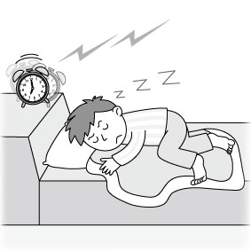 (Ｂ)　 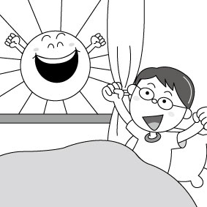 (Ｃ) 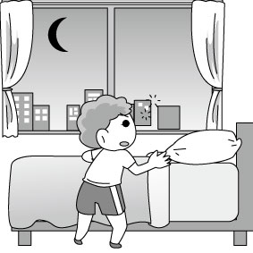

2. （**A**） The koala and the dog are 8 kilograms in total.  
(Ａ)　 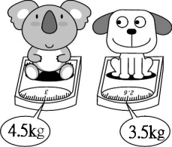 (Ｂ)　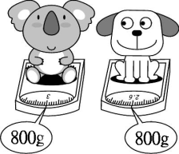 (Ｃ)　 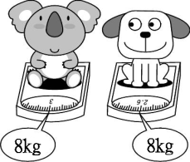

3. （**B**） The blind man is walking on the sidewalk.  
(Ａ)　 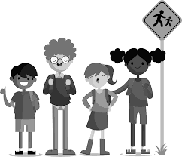 (Ｂ)　 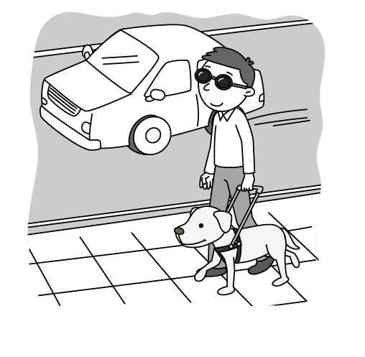 (Ｃ)　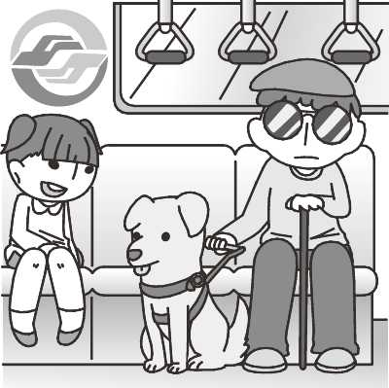

4. （**B**） If I have free time, I will sit alone by the river and watch the fish swimming in it.  
(Ａ)　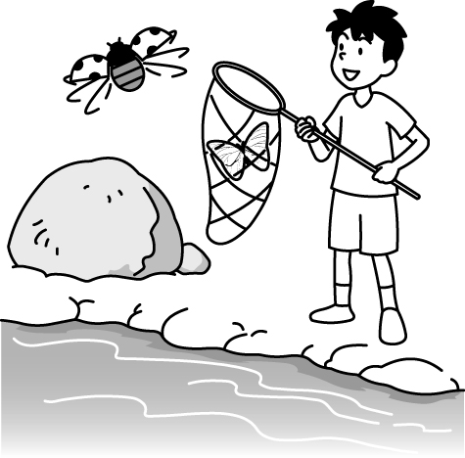 (Ｂ)　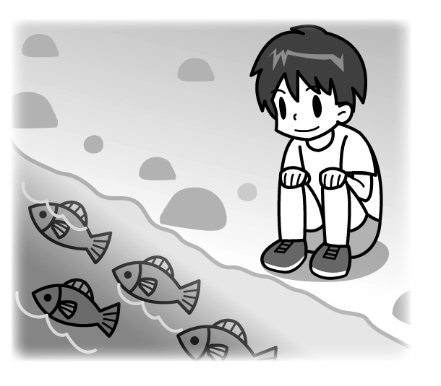 (Ｃ)　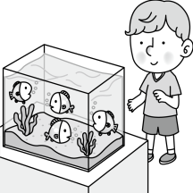

5. （**A**） To fall asleep soon, Mark reads books before going to bed.  
(Ａ)　 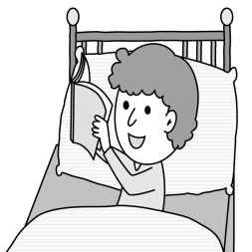 (Ｂ)　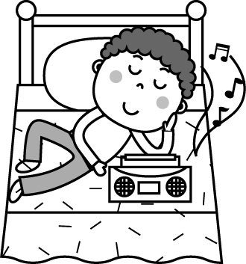 (Ｃ)　 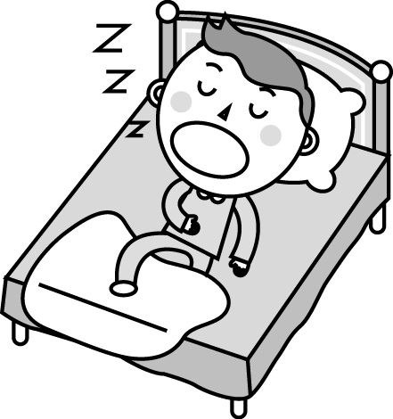

二、字彙選擇：根據題意，選出一個最適合的答案。

6. ( **B** ) Hi, my ________ is Jason. I am Ruby’s brother.

(Ａ)　number　 (Ｂ)　name　 (Ｃ)　phone

7. ( **C** ) Allen: What’s your ________? Iris: It’s 2871-886.

(Ａ)　birthday　 (Ｂ)　name　 (Ｃ)　phone number

8. ( **A** ) There are four ________ in a year. They are spring, summer, fall and winter.

(Ａ)　seasons　 (Ｂ)　months　 (Ｃ)　days

9. ( **B** ) John is a great ________.　He teaches English in QP Junior High school.

(Ａ)　farmer　 (Ｂ)　teacher　 (Ｃ)　singer

10. ( **B** ) A : What’s your favorite ________ ? B : It’s pink.

(Ａ)　animal　 (Ｂ)　sport　 (Ｃ)　color

三、語法選擇：根據題意，選出一個最適合的答案。

11. ( **C** ) A : Is that car Mr. Wang’s? B : ________.

(Ａ) Yes, he is.　 (Ｂ) Yes, they are.　 (Ｃ) Yes, it is.

12. ( **B** ) You are ________ young ________ ride a motorcycle.

(Ａ)　such; ×　 (Ｂ)　too; to　 (Ｃ)　so; that

13. ( **C** ) A :What are those? B :They are ________.

(Ａ)　toy car　 (Ｂ)　a toy car　 (Ｃ)　toy cars

14. ( **A** ) I enjoy ________ baseball with my friends after school.

(Ａ)　playing　 (Ｂ)　to play　 (Ｃ)　play

15. ( **B** ) They have lived in Taoyuan ________ 2003.

(Ａ)　in　 (Ｂ)　since　 (Ｃ)　for

16. ( **C** ) There ________ many apples in the basket. Do you want some?

(Ａ)　have　 (Ｂ)　is　 (Ｃ) are

17. ( **A** ) A : How does the cake ________? 　B : Very delicious.

(Ａ)　taste　 (Ｂ)　feel　 (Ｃ)　sound

18. ( **C** ) A : What are you doing? B : I’m ________ a card for my mom.

(Ａ)　makes　 (Ｂ)　made (Ｃ)　making

19. ( **B** ) Anna: ________ is our new neighbor from?

Lily: He is from Japan.

(Ａ)　How　 (Ｂ)　Where　 (Ｃ)　When

20. ( **A** ) Do you know the girl ________ long hair?

(Ａ)　with　 (Ｂ)　in　 (Ｃ)　on

21. ( **A** ) Sally: ________ is Grandma’s birthday party?

David: It’s next Sunday.

(Ａ)　When　 (Ｂ)　Where　 (Ｃ)　Who

22. ( **A** ) Where ________ Peter go next week?　He will go to Tainan.

(Ａ)　will　 (Ｂ)　do　 (Ｃ)　are

23. ( **C** ) I don’t like summer ________ it’s too hot.

(Ａ)　so　 (Ｂ)　although　 (Ｃ)　because

24. ( **A** ) Alex: How does Old Joe go to work? Brian: He goes to work ________ .

(Ａ)　on foot　 (Ｂ)　by foot　 (Ｃ)　walk

25. ( **A** ) Ben always ________ homework by himself. No one helps him.

(Ａ)　does　 (Ｂ)　do　 (Ｃ)　did

26. ( **C** ) ________ turned off the fan? Ivan did.

(Ａ)　What　 (Ｂ)　Where　 (Ｃ)　who

27. ( **C** ) Mom asked me ________ the dishes after dinner.

(Ａ)　do　 (Ｂ)　doing　(Ｃ)　to do

28. ( **A** ) A : What was Rita doing at that time?　B : She ________ in her room.

(Ａ)　was reading 　 (Ｂ)　read　 (Ｃ)　reads

29. ( **C** ) Which is ________, the guava, the lemon, or the apple?

(Ａ)　lighter　 (Ｂ)　lightest　 (Ｃ)　the lightest

30. ( **B** ) Sam is ________ than me.

(Ａ)　tall　 (Ｂ)　taller　 (Ｃ)　the tallest