桃園市立青埔國中 110 學年度第 2 學期 九年級語文領域總補考題庫
領域  （科目） | 英文 | 範圍 | 第一~六冊 |  |  | 得分
班級 | 年 班 | 姓名 |  | 座號 |  | 得分
一、字彙選擇(應用字彙)：每格2分、共44分
( D )1. 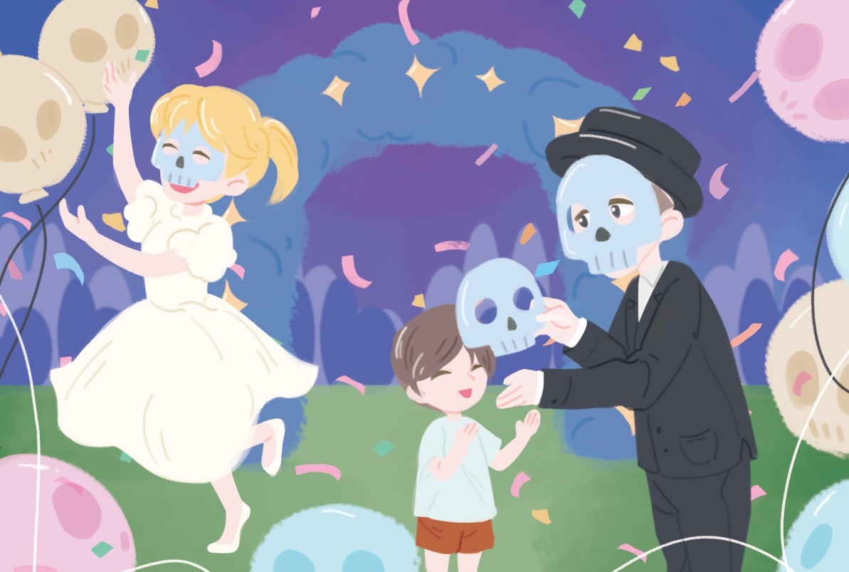
Let’s the Day of the Dead.
(A)fight (B)paint (C)share (D)celebrate
( C )2. 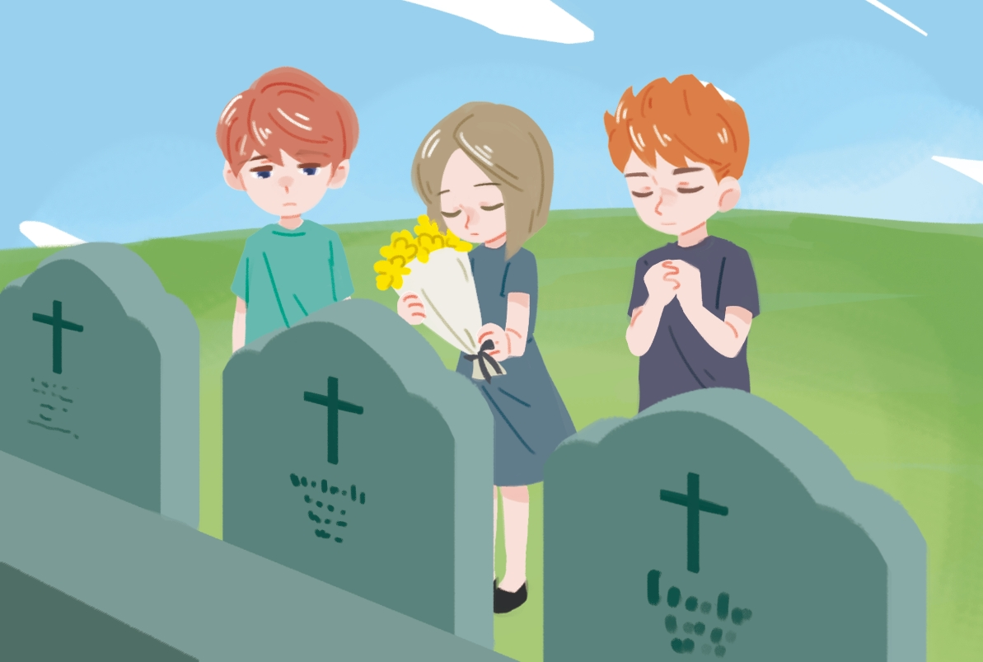
My good friend, Jack, three years ago.
(A)moved in (B)checked in (C)passed away (D)walked away

( D )3. 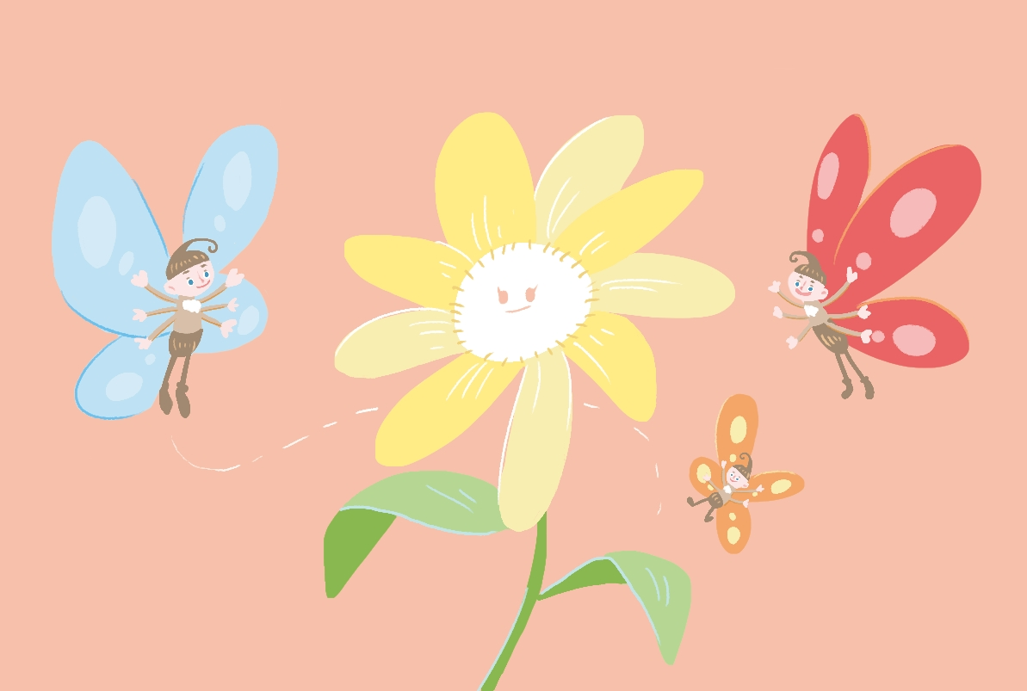
There are some around the flowers.
(A)bats (B)bees (C)birds (D)butterflies
( A )4. 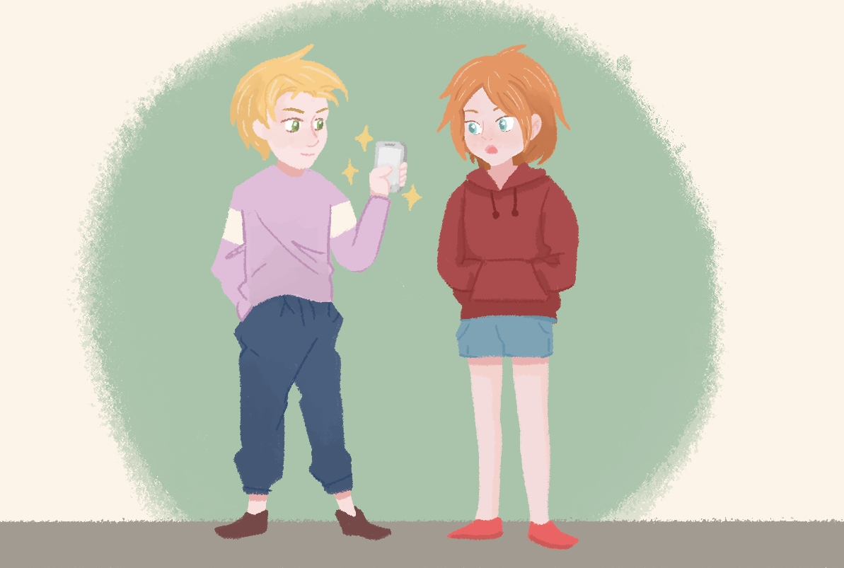
I bought a new yesterday.
(A)cellphone (B)computer (C)television (D)telephone
( B )5. 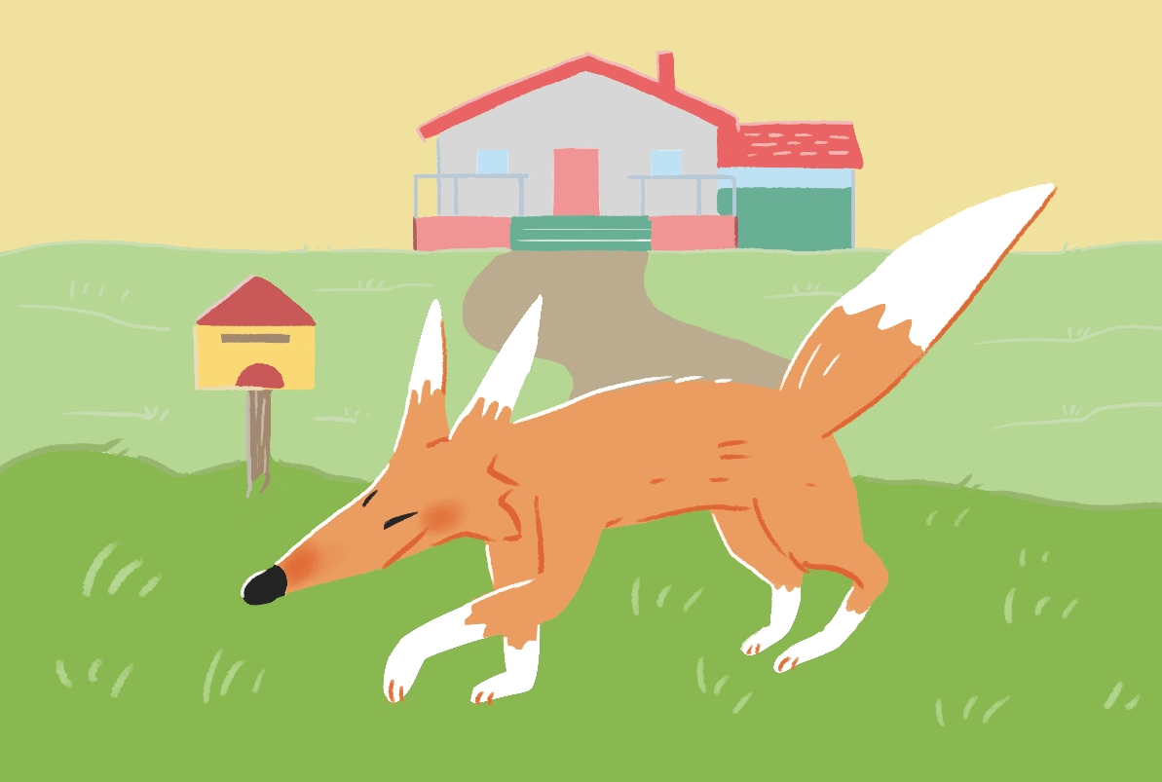
Look! Is there a near the house?
(A)cat (B)fox (C)lion (D)dog
( B )6. 
There is coffee in the cup.
(A)few (B)little (C)many (D)much
( D )7. 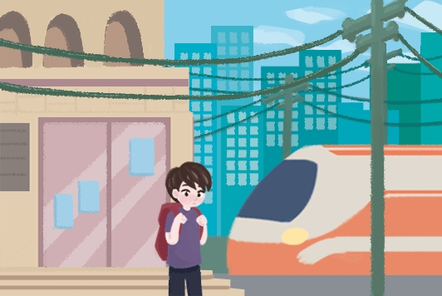
Luke was waiting for someone at the yesterday morning.
(A)bank (B)farm (C)hotel (D)train station
( A )8. My sister was really ______ at me because I ate her cake.
(A)mad (B)lazy (C)weak (D)polite
( B )9. Jimmy: Is Jenny in her ______? Judy: No, she’s not there. She went out this morning.
(A)band (B)office (C)window (D)square
( D )10. The ______ show on New Year’s Eve was really amazing and colorful.
(A)stair (B)noise (C)scream (D)fireworks
( A )11. ______ class is Flora’s favorite. She enjoys swimming and running
with her classmates.
(A)PE (B)Art (C)Math (D)Science
( A )12. Anderson is _______ a hole to hide his favorite toy.
(A)digging (B)dropping (C)fooling (D)teaching
( A )13. Don’t be _______ by Jacky. He took the money, not Rita.
(A)fooled (B)dropped (C)dug (D)interested
( D )14. Watch out! There is a big rock ______ down the hill.
(A)driving (B)expecting (C)climbing (D)rolling
( C )15. There is no school tomorrow because it’s a ______ holiday.
(A)glad (B)born (C)national (D)surprised
( D )16. Is there life on other _______?
(A)pets (B)pipes (C)songs (D)planets
( B )17. The man in the _______ coat is my dentist.
(A)glad (B)gray (C)correct (D)round
( C )18. Nelson always studies hard, so he gets good ______on every subject.
(A)sides (B)tests (C)grades (D)quizzes
( C )19. Tom,______ , or you will be late for the show.
(A)pop up (B)stay up (C)hurry up (D)hand up
( A )20. Don’t ______. The teacher already knows everything about it.
(A)tell a lie (B)get a prize (C)join a race (D)buy a present

二、文法：每格2分、共40分
( A )1. is a bird in the tree.
(A)There (B)This (C)Here (D)They
( B )2. Amy: there any books on the desk?
Ben: Yes, there are.
(A)Is (B)Are (C)Isn’t (D)Are not
( B )3. Daniel: is my pen?
Mom: It’s in your pencil box.
(A)Why (B)Where (C)Who (D)How
( D )4. There any students at school a week ago.
(A)isn’t (B)aren’t (C)wasn’t (D)weren’t
( C )5. Peter: Who the sofa in the living room?
Julia: My father did.
(A)move (B)moves (C)moved (D)moving
( C )6. Rene: you busy this morning?
Gwen: Yes, I .
(A)Was; was (B)Did; did (C)Were; was (D)Were; were
( C )7. Ken: did John do this morning?
Mandy: He did nothing.
(A)Why (B)How (C)What (D)Where
( A )8. Alex: Did Hank any sport today?
Irene: No, he was at home.
(A)play (B)plays (C)played (D)playing
( D )9. Ruby when her brother opened the door.
(A)cook (B)cooks (C)is cooking (D)was cooking
( B )10. Before Tracy famous, she only sang at the restaurant.
(A)become (B)became (C)is becoming (D)was becoming
( A )11. Studying English very important.
(A)is (B)am (C)are (D)can
( B )12. It is difficult for them this story.
(A)understand (B)to understand (C)understood (D)understanding
( B )13. James: How are you?
Gail:
(A)Good night. (B)I'm fine. Thank you. (C)Nice to meet you, too. (D)Good afternoon.
( C )14. Sam: What is your phone number?
Rita:
(A)It is Lucky. (B)It is my dog. (C)It is 22438607. (D)It’s a cellphone.
( C )15. The song is ______by my favorite singer. I enjoy listening to it a lot.
(A)sing (B)sang (C)sung (D)singing
( C )16. Dan has already ______his homework, so he can play the computer game now.
(A)finish (B)finishes (C)finished (D)finishing
( C )17. Do you know ______playing a video game alone?
(A)who Ben is (B)who is Ben (C)why Ben is (D)why is Ben
( C )18. Larry doesn’t know ______. His mom says that she will teach him.
(A)who to talk (B)where to go (C)how to cook (D)when to leave
( C )19. I don’t like dogs ______have long tails.
(A)who (B)what (C)which (D)where
( A) 20. Mike is an old man______ lives on his own.
(A)who (B)what (C)when (D)which
三、克漏字選擇：每格2分、共16分
- Mr. and Mrs. Lu have three children; they are Steven, Carol, and Betty. In the past, they were always busy with their children. They worked during the daytime and took care of their children at night. Mr. and Mrs. Lu’s life (１)______a lot since last year. Carol married Bruce, (２)______a businessman, and they moved out of town. In the beginning of this year, Steven married Tiffany, (３)______at a senior high school. They also moved into their own house near the school. Betty is not married yet, but she (４)______abroad next month to study. After Betty leaves, Mr. and Mrs. Lu can plan for a future (５)______their children.
( C ) (１)(A) changed (B) is changing (C) has changed (D) can be changed
( D ) (２)(A) is (B) that is (C) which is (D) who is
( B ) (３)(A) teaches (B) who teaches (C) will teach (D) has taught
( A ) (４)(A) will go (B) has been (C) has gone (D) went
( D ) (５)(A) no (B) with (C) none (D) without
- Molly was happy because she would soon be going on a field trip(校外教學) to Taipei Zoo with her class. She was (１)______ the trip. She couldn’t sleep because she couldn’t wait to travel with her classmates. The next day, however, (２)______. First, Molly slept late. So, she had to run to school. She made it on time, but when she arrived at the zoo, she couldn’t find her wallet. She asked her classmates, “Do you know (３)______?” Her classmates said that they didn’t know. After a while, Molly remembered that she forgot to bring her wallet. Luckily, her classmate, Leila, lent her some money, so she could buy the ticket. Molly learned a lesson that she needed to get up on time and remember to pack up(打包) earlier.
( D ) (１) (A) tired of
(B) surprised at
(C) interested in
(D) excited about
( B ) (２) (A) she woke up very early
(B) some bad things happened
(C) she remembered to bring her bag
(D) her mom told her not to go to the trip
( C ) (３) (A) which my wallet is
(B) which is my wallet
(C) where my wallet is
(D) where is my wallet

