桃園市立青埔國中 107學年度第2學期7年級補考大補帖
領域  （科目） | 英語 | 範圍 | 康軒L1-R3 |  |  | 得分
班級 | 年 班 | 姓名 |  | 座號 |  | 得分

      - 選出正確的單字

- ___B___ 工程師
(A) businessman (B) engineer (C) player (D) singer
- ___C___ 接住
(A) nod (B) shake (C) catch (D) fix
- ___A___ 事情
(A) thing (B) story (C) baseball (D) class
- ___D___ 可怕的
(A) bad (B) excellent (C) nice (D) terrible
- ___C___ 籃球
(A) baseball (B) tennis (C) basketball (D) sport
- ___B___ 學習
(A) give (B) learn (C) look at (D) help
- ___D___ 自然科學
(A) history (B) music (C) subject (D) science
- ___A___ 也許
(A) maybe (B) p.m. (C) sure (D) still
- ___B___ 自己的
(A) loud (B) own (C) free (D) exciting
- ___C___ 第十九個
(A) third (B) eighth (C) nineteenth (D) twentieth
- ___D___ 十二月
(A) January (B) March (C) November (D) December
- ___B___ 通常
(A) seldom (B) usually (C) always (D) never
- ___A___ 小提琴
(A) violin (B) guitar (C) drum (D) piano
- ___B___ 放學後
(A) make friends (B) after school (C) too bad (D) at least
- ___B___ 慶祝
(A) miss (B) celebrate (C) wish (D) choose
- ___D___ 離…之遠
(A) why (B) again (C) sure (D) away
- ___B___ 那麼、然後
(A) soon (B) then (C) often (D) first
- ___A___ 足夠的
(A) enough (B) fair (C) difficult (D) nearsighted
- ___A___ 木瓜
(A) papaya (B) tomato (C) guava (D) peach
- ___D___ 盤
(A) glass (B) bowl (C) spoon (D) plate

      - 選出正確的親屬關係
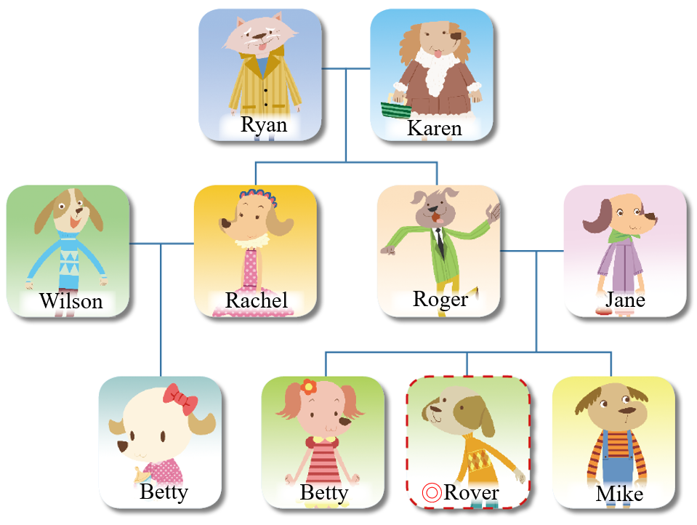
- Ryan is Rover’s A . (A) grandfather (B) father (C) cousin (D) brother
- Wilson is Rover’s C . (A) brother (B) father (C) uncle (D) brother
- Betty is Rover’s D . (A) grandmother (B) mother (C) cousin (D) sister
- Mike is Rover’s D . (A) grandfather (B) father (C) cousin (D) brother
- Rachel is Rover’s B . (A) grandmother (B) aunt (C) cousin (D) sister
- Karen is Rover’s A . (A) grandmother (B) aunt (C) cousin (D) sister
- Roger is Jane’s B . (A) grandfather (B) husband (C) uncle (D) brother
- Karen is Ryan’s B . (A) mother (B) wife (C) daughter (D) sister

- 填入適當的回應句代號。
( D ) 1. What do you like?
( A ) 2. Can Betty read?
( B ) 3. Is Jason an actor?
( C ) 4. Are the movies terrible?
A. No, she can’t.
B. Yes, he is.
C. No, they aren’t.
D. I like robots.

- 依表格內容選出相符的科目名稱。

 | English | Math | Chinese | music | PE
Sophia | O | X | X | X | O
Kevin | O | O | X | O | X
David | X | X | O | O | X
Cindy | X | O | O | X | O
  - O = like、X = doesn’t like

- Sophia likes _____C_____. (A) math (B) music (C) English (D) Chinese
- Kevin doesn’t like _____B_____. (A) English (B) math (C) music (D) PE
- David likes _____A_____. (A) Chinese (B) PE (C) English (D) math
- Cindy doesn’t like _____C_____. (A) Chinese (B) math (C) music (D) PE

- 看圖選出星期名稱。
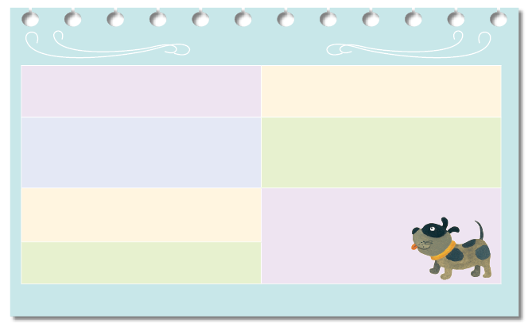
Sun. 9:30: Play badminton at
the club Thu. Study math
Thu. Study math
Mon. Study math
Fri. 15:00: Practice the guitar
with Tom
Tue. 19:00: Have violin
lessons
Wed. Study Chinese
Sat. Train Spot
 schedule 行程表
Brian’s Schedule
1. Brian studies Chinese every C . (A) Monday (B) Tuesday (C) Wednesday (D) Thursday
2. He practices the guitar with Tom every C . (A) Wednesday (B) Thursday (C) Friday (D) Saturday
3. He goes to the badminton club every A . (A) Sunday (B) Monday (C) Tuesday (D) Wednesday
4. He has violin lessons every B . (A) Monday (B) Tuesday (C) Wednesday (D) Thursday
5. He plays with his dog every C . (A) Thursday (B) Friday (C) Saturday (D) Sunday

- 填入適當的問句，完成對話。

- Why do you take PE?  - When does the first bus come? | - What’s the date today?  - What days do you go to the chess club?

1. A: _C B: It’s October nineteenth.
2. A: You don’t like sports. A B: I like the teacher. She is beautiful.
3. A: B B: At around six fifteen.
4. A: D B: On Wednesdays and Thursdays.

- 填入適當的回應句代號。
A. Chocolate.
B. I want a robot.
C. At the food store.
D. She likes guavas.
( C ) 1. Where is your brother?
( D ) 2. Which does Tina like, guavas or papayas?

( B ) 3. Which do you want, a robot or a frisbee?
( A ) 4. Let’s have some ice cream. What flavor do you want?

- 選出正確答案
1. B salt do you need? (A) How many (B) How much
2. A cats does Tina have? (A) How many (B) How much
3. B green tea does Michael want? (A) How many (B) How much
4. A pens are there on the desk? (A) How many (B) How much
5. A peaches are there in the box? (A) How many (B) How much
6. B chocolate is there in the bag? (A) How many (B) How much

- 看圖填入適當的設施名稱。
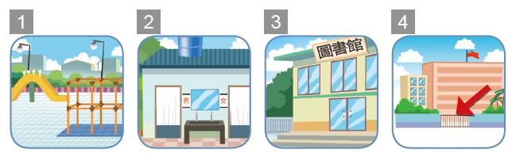

(A) playground (B) library (C) restroom (D) gate

1. A 2. C 3. B 4. D

